English Manuscript Title 8-15 words, Capital Each Word (Except Conjunctions), Cambria font size 14

First Author^{1*}, Second Author ², Third Author ³
(If all authors come from the same institution, then no coding will be given)
¹First Author Institution
²Second Author Institution
³Third Author Institution
*Authors Correspondence: Email Address/Phone Number
Keywords:  Keyword 1;  keyword 2;  keyword 3;  keyword 4;  keyword 5; |  | ABSTRACT  Abstract written in English. This template is a guide format for writing articles in the Media Kesehatan Masyarakat Indonesia journal (MKMI) which has been adapted to the style of the MKMI journal. Authors should follow the instructions given in this manual. This document can be used as a reference in writing the author manuscript. Make sure not to change the existing styles on this template, including font type and size, spacing, indent spacing, etc. The maximum number of pages for the MKMI journal is 15 pages. If there are foreign terms that have not been standardized, they are written in Italic. The abstract is made in 1 whole paragraph in English and completely describes the essence of the actual writing. Abstract writing of a maximum of 250 words containing the scope of the research carried out by emphasizing preliminary data from general to specific data, using 10 points Cambria font, spaced 1. The abstract contains the introduction, namely the background of why the research needs to be researched (1-2 sentences), research objectives that are described briefly, concisely, and clearly (1 sentence), materials and methods, including research design, sample size, data collection techniques, and research time and analysis techniques used (3 -5 sentences), research results/findings (3-5 sentences), conclusions, containing the implications of the findings/results which are explained briefly and containing suggestions (1 sentence). xxxxx xxx xxxxx xxxxx xxxx xxxxxx xxxxx x xxxxx xxxxx xxxx xxxx xxx xxxx xxxxx xxxxx xxxx xxxxx xxxxx xxxxx xxxxxx xxxx xxxxxx xxx xxx.

INTRODUCTION
The introduction contains the urgency and background of the research problem described by the inverted pyramid method starting from the global, national and local levels. Include references (relevant literature or research results) using the source number in each sentence after the dot (.) which is adjusted to the Bibliography, for example: Strasburger et al.'s research show that adolescents aged 8-18 years spent an average of 7 hours per day accessing media.¹
The number of pages in the introduction is 1-1.5 pages written using Cambria 11 points (upright) with 1.0 spacing. Each paragraph begins with a word that is indented into five digits. The final section of the introduction should state the purpose of the research.

MATERIAL AND METHOD
This section describes the type of research, the location and time of the study, the population and sample, sampling techniques, data collection techniques, data analysis, and data presentation. Research that uses tools and materials needs to write down the specifications of the tools and materials used. Qualitative research such as case studies, phenomenology, ethnography, and others, need to add a description of checking the validity of research results. The final part of the materials and methods of the author must include Ethical Clearance, the writing using Cambria 11 points (upright) with 1.0 spacing. Paragraphs begin with words indented into five digits and this section is shown in 1-2 paragraphs.
RESULTS
The results contain the research output by describing the factual and valid findings, objectives, and research methods. The results section describes the characteristics of the research subjects, univariate analysis, bivariate analysis and multivariate analysis (if any). An example of writing statistical results is the results of the study showing xxxxxxxxxxxxxx xxx (p = 0,000; OR = 45,25; 95% CI = 13,23 < OR < 154,72) against Z disease.

Format Tables, Mathematical Formulas, Diagrams, and Figure
The table title is placed above the table. Each table and figure must be numbered (e.g.: “Table 1”, “Figure 1”). Tables are typed one spaced and numbered sequentially according to their appearance in Cambria (Bold) letters font size 10. Writing tables do not use vertical lines but only horizontally. The maximum number of 5 tables and figure with short and complete titles.
The presentation of tables, figures, and formulas should not precede the narrative
The writing in tables, diagrams, and figure uses Cambria Size 10 format except for descriptions of image sources and tables using Cambria Size 9.
Figure
The figure is placed after the narration of the figure. Images cannot be framed. The legend or description of the image is at the bottom or side of the image; it must not be above the image. The caption or title of the image is under the image in question using Cambria 10 point (Bold) format. Image resolution must be high so as not to break the image. The legend or description of the image is placed below/next to the diagram; it must not be above the image. The source of the image (if not the result of research) is placed under the legend/diagram description.
A narrative about the image (Figure 1).
Diagram/Grafik
Making diagrams in the form of bar, line or circle charts, use two-dimensional diagrams without frames. The narration is placed before the diagram. The narration is not a repetition of the narrated diagram. The diagram's title is below the description or source of the relevant diagram using Cambria 10 point (Bold) format. Diagram includes to the category of images. A narrative about the diagram (Figure 2).
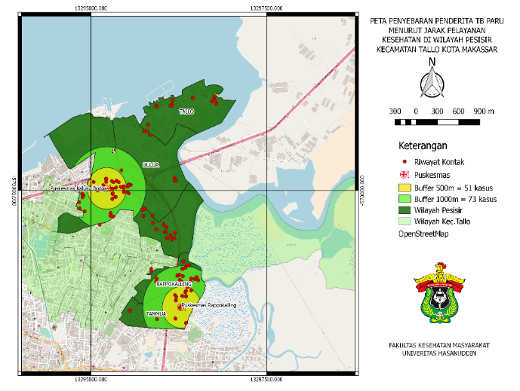

Source: Primary Data, 2020
Figure 1. Figure Title
(Capital Letters at the Beginning of Words Except for Prepositions and Connecting Words)
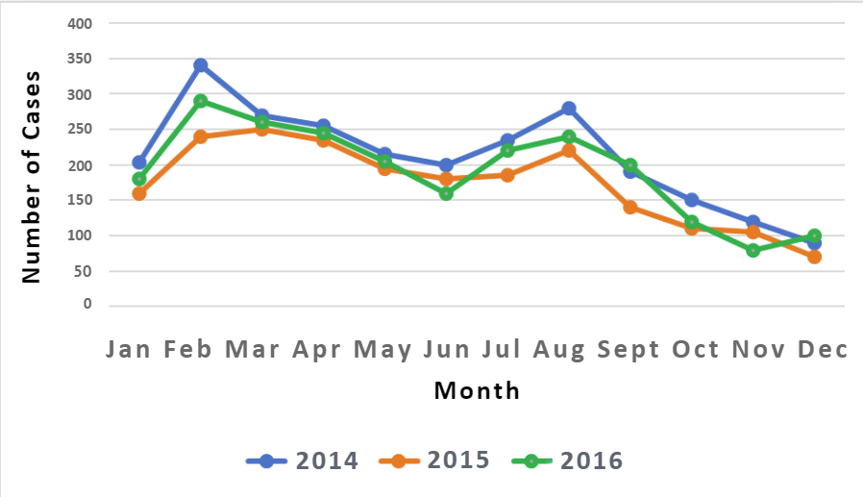
Source: Secondery Data of Dinas Kesehatan Kota Makassar, 2020
Figure 2. Figure Title
Math Formula
It is recommended to write mathematical formulas using Mathtype or Equation Editor in Word and written left aligned. The rule of math formulas is Font Cambria Math Size 11.
Formula writing should not be separated from the narrative, the formula is indicated using a colon without a space (:). Example:
This study uses the formula X (1994) which is shown as follows:
$$X=\frac{dy}{dx}×\frac{-b±\sqrt{b^{2}-4ac}}{2a}=c$$
Table
Table titles should be centered and written in bold, while variable and sub-variable names should be left-aligned. If a variable consists of several categories, the main variable name should be written in bold. Decimal numbers should be presented with two digits after the decimal point. The narrative or interpretation of the table must be presented before the table and should not merely repeat the table contents descriptively, but rather be aligned with the research objectives. For example, “Most respondents were aged 20–35 years (Table 1).”
Tables should not be split across different pages. Splitting a table is only permitted if it exceeds one page, provided that the table starts at the top of the following page. Each table must include the data source, whether primary or secondary data, along with the year of data collection. Tables should not be placed in the middle of or between text; instead, they should be positioned at the top or bottom of the page to ensure a clear and logical reading flow.
Table 1. Title of Table (Capital Letters at the Beginning of Words Except for Conjunctions)
Characteristics | n = (Total Sample) | %
Age (Year)
< 20 | XX | XX.XX
21-30 | XX | XX.XX
31-40 | XX | XX.XX
Education
Elementary School Graduation | XX | XX.XX
Graduated Junior High School | XX | XX.XX
High School Graduation | XX | XX.XX
Graduated College | XX | XX.XX
Labor
No Postterm | XX | XX.XX
Postterm | XX | XX.XX
Aaaaaaaa
Aaaaaaa | XX | XX.XX
Aaaaaaa | XX | XX.XX
Bbbbbbb
Bbbbbb | XX | XX.XX
Bbbbbb | XX | XX.XX
Source: Primary Data, 2021
Table 2. Title of Table
Variable | Disease Incidence X |  |  |  | p-value | OR value (95%CI)
 | Yes |  | No
 | n | % | n | %
Age (Year)
< 20 | XX | XX.XX | XX | XX.XX | X.XXX | OR value  (LL-UL)
21-30 | XX | XX.XX | XX | XX.XX
31-40 | XX | XX.XX | XX | XX.XX
Merital Status
Merried | XX | XX.XX | XX | XX.XX | X.XXX | OR value
Not Merried | XX | XX.XX | XX | XX.XX |  | (LL-UL)
Source: Primary Data, 2021
DISCUSSION
The discussion contains interpretation of research results, linking research results with relevant theories, literature and previous findings. The discussion is not repeating the results. Aspirations of insight are universal, preferably sources on an international scale compared to national scale and do not come from the related university environment because they are considered to have very local aspirations. Writing on the results and discussion ± 55% of the total page.
CONCLUSION AND RECOMMENDATION
Conclusions and recommendations contain a summary of the description of the results and discussion with reference to the research objectives. Suggestions are prepared based on the research findings that have been discussed. Suggestions may refer to practical action, the development of new theories, and/or further research. Writing conclusions and suggestions using Cambria 11 points (upright) with 1.0 spacing. Paragraphs begin with words that are indented into 5 digits and may not use bullets or numbers. This section is displayed in 1-2 paragraph.

ACKNOWLEDGMENTS
Acknowledgments can be given to the parties to provide financial assistance.
AUTHOR CONTRIBUTIONS
For research articles with several authors, a short paragraph specifying their individual contributions could be provided. The following statements should be used “Conceived and designed the experiments by ILM and ID; H performed the experiments; UQ and GFS analyzed the data; ASY contributed reagents/materials/analysis tools and wrote the manuscript. The authors read and approved the final manuscript. ILM = Ida Leida Maria; ID = Indra Dwinata; H = Hardianti; UQ = Ummul Qura; GFS = Ghea Fricillia Sambe; ASY = Andi Selvi Yusnitasari”.
CONFLICTS OF INTEREST
Declare conflicts of interest or state “The authors declare no conflict of interest." Authors must identify and declare any personal circumstances or interests that may be perceived as inappropriately influencing the representation or interpretation of reported research results. Any role of the funding sponsors in the design of the study; in the collection, analysis, or interpretation of data; in the writing of the manuscript, or in the decision to publish the results must be declared in this section. If there is no role, please state “The founding sponsors had no role in the design of the study; in the collection, analyses, or interpretation of data; in the writing of the manuscript, and in the decision to publish the results”.

REFERENCES
The bibliography is written according to the Vancouver superscript style of writing. All references used in writing in the bibliography are numbered according to their appearance in the article, not alphabetically. Only include the literature used in the articles made and relevant to the research. Reference sources at least 15 references (70% of the latest journal articles in the last 5 years) and (30% from other sources such as books, theses, theses, dissertations, reports, and regulations with the rules of the last 10 years and still relevant). To maintain a consistent way of referring, citing and writing bibliography we recommend using standard reference applications such as Mendeley, Endnote or Zotero.
Example of writing references:
1. Openshaw JJ, Medina A, Felt SA, et al. Prevalence and Risk Factors for Taenia Solium Cysticercosis in School-Aged Children: A School Based Study in Western Sichuan, People’s Republic of China. PLoS Neglected Tropical Diseases. 2018;1(2):1-23.
https://journals.plos.org/plosntds/article?id=10.1371/journal.pntd.0006465
(Example: Article Internasional)
2. Yusnitasari AS, M. Thaha IL, Syafar M. Comorbidity Diabetes Mellitus toward Clinical Manifestations and Quality of Life in Patients Pulmonary Tuberculosis. Media Kesehatan Masyarakat Indonesia. 2016;11(2):86-91. https://doi.org/10.30597/mkmi.v11i2.529
(Example: Article Nasional)
3. Ahrens W, Pigeot I. Handbook of Epidemiology. 2nd ed. New York: Springer; 2014.
(Example: Book)
4. Murti B. Teori Promosi dan Perilaku Kesehatan. 1st ed. Surakarta: Bintang Fajar Offset; 2018. (Example: Book)
5. Kemenkes RI. Riset Kesehatan Dasar (Riskesdas). Jakarta: Kementerian Kesehatan RI; 2018. (Example: Report)
6. Dwinata I, Dian Pratiwi Ahmad, Arsyad DS. Why Coverage of Pentavalent Booster Immunization in Sinjai Still Low? In: The 3rd International Confrence on Enviromental Risk and Public Health. Makassar: Departement of Enviromental Health Hasanuddin University; 2018.
(Example: Prosiding Confrence)
Editorial Note:
The submitted manuscripts must undergo thorough proofreading and editing. Ensuring your manuscript is polished and free from errors will significantly enhance its quality and increase the chances of successful publication.
Please make sure that your manuscript is carefully proofread and edited for clarity, grammar, and consistency before submission. If you need assistance with professional editing services, we are happy to provide recommendations.
Thank you for your attention to this important matter.
Best regards,
MKMI Editorial Office

